**[Python program to print Emojis - GeeksforGeeks](https://www.geeksforgeeks.org/python-program-to-print-emojis/)**

There are multiple ways we can print the Emojis in Python. Let’s see how to print Emojis with Unicodes, CLDR names and emoji module.   
**Using Unicodes:**  
Every emoji has a Unicode associated with it. Emojis also have a CLDR short name, which can also be used.   
From the list of unicodes, replace “+” with “000”. For example – “U+1F600” will become “U0001F600” and prefix the unicode with “\” and print it.

**Python3**

|  |
| --- |
| # grinning face  print("\U0001f600")    # grinning squinting face  print("\U0001F606")    # rolling on the floor laughing  print("\U0001F923") |

**Output:** 

**Using CLDR short name:**

**Python3**

|  |
| --- |
| # grinning face  print("\N{grinning face}")    # slightly smiling face  print("\N{slightly smiling face}")    # winking face  print("\N{winking face}") |

**Output:** 

**Using emoji module:**  
Emojis can also be implemented by using the emoji module provided in Python. To install it run the following in the terminal.

pip install emoji

emojize() function requires the CLDR short name to be passed in it as the parameter. It then returns the corresponding emoji. Replace the spaces with underscore in the CLDR short name.

**Python3**

|  |
| --- |
| # import emoji module  **import** emoji      **print**(emoji.emojize(":grinning_face_with_big_eyes:"))  **print**(emoji.emojize(":winking_face_with_tongue:"))  print(emoji.emojize(":zipper-mouth_face:")) |

**Output:** 

demojize() function converts the emoji passed into its corresponding CLDR short name. 

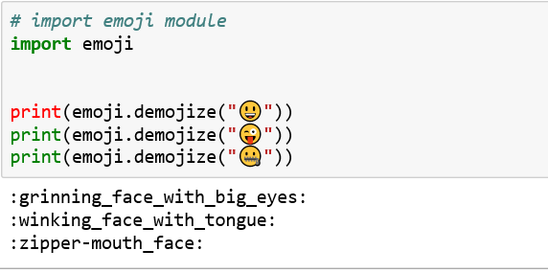

Below is a list of some common emoji Unicodes with their CLDR short names:

| **CLDR Short Name** | **Unicode** |
| --- | --- |
| grinning face | U+1F600 |
| grinning face with big eyes | U+1F603 |
| grinning face with smiling eyes | U+1F604 |
| beaming face with smiling eyes | U+1F601 |
| grinning squinting face | U+1F606 |
| grinning face with sweat | U+1F605 |
| rolling on the floor laughing | U+1F923 |
| face with tears of joy | U+1F602 |
| slightly smiling face | U+1F642 |
| upside-down face | U+1F643 |
| winking face | U+1F609 |
| smiling face with smiling eyes | U+1F60A |
| smiling face with halo | U+1F607 |
| smiling face with 3 hearts | U+1F970 |
| smiling face with heart-eyes | U+1F60D |
| star-struck | U+1F929 |
| face blowing a kiss | U+1F618 |
| kissing face | U+1F617 |
| smiling face | U+263A |
| kissing face with closed eyes | U+1F61A |
| kissing face with smiling eyes | U+1F619 |
| face savoring food | U+1F60B |
| face with tongue | U+1F61B |
| winking face with tongue | U+1F61C |
| zany face | U+1F92A |
| squinting face with tongue | U+1F61D |
| money-mouth face | U+1F911 |
| hugging face | U+1F917 |
| face with hand over mouth | U+1F92D |
| shushing face | U+1F92B |
| thinking face | U+1F914 |
| zipper-mouth face | U+1F910 |
| face with raised eyebrow | U+1F928 |
| neutral face | U+1F610 |
| expressionless face | U+1F611 |
| face without mouth | U+1F636 |
| smirking face | U+1F60F |
| unamused face | U+1F612 |
| face with rolling eyes | U+1F644 |
| grimacing face | U+1F62C |
| lying face | U+1F925 |
| relieved face | U+1F60C |
| pensive face | U+1F614 |
| sleepy face | U+1F62A |
| drooling face | U+1F924 |
| sleeping face | U+1F634 |
| face with medical mask | U+1F637 |
| face with thermometer | U+1F912 |
| face with head-bandage | U+1F915 |
| nauseated face | U+1F922 |